

Quick Reference Guide
PM/SM + PPM

Contents
Roles in This Guide 2
Time Grain Defaults 3
Sign-in and Homescreen 4
Homescreen for PM/SM 5
Homescreen for RM 5
Top Bar Reference 6
Notification Subscriptions 6
Find and Open a Project 7
Open Project Management 7
View Management 7
PROJECT ATTRIBUTES (master data) 9
SINGLE PROJECT ALLOCATION GRID 10
Create a Project 13
Project Master Data (Attributes) 14
Editing Rules 14
What to Maintain 14
What PM/SM Cannot See / Edit 15
Plan Resources (Allocations) 15
Toolbar Reference 16
Add a Resource 17

Roles in This Guide
Badge | Knauf Global Role | Typical day-to-day
PM/SM | Project Manager / Service Manager | Owns one or more projects/services; maintains master data, plans labor and non-labor costs, watches own projects.
RM | Resource Manager | Steers capacity across the pool; handles resource requests; bulk-edits allocations across many projects.
Both | Applies to PM/SM and RM | Sign-in, navigation, opening a project, reporting basics.

Note: IT-Controlling, Admin Light, and Executive Users exist in Tempus but follow separate training material. They may share screens with planners but with different rights.

Time Grain Defaults
Screen | Default at Knauf
Single Project Allocations | Month
Bulk Project Allocation Flatgrid (RM) | Month
Financials | Quarter

Tip: You can always switch grain (Day, Week, Month, Quarter, Year) from the dropdown above the grid. The granularity only affects display, not the underlying values.

Sign-in and Homescreen
Both

• Open https://knaufdev.tempus-resource.com/ (sandbox) or your production URL in Chrome.
• Use SSO in production, or the local Log In for sandbox/training accounts.
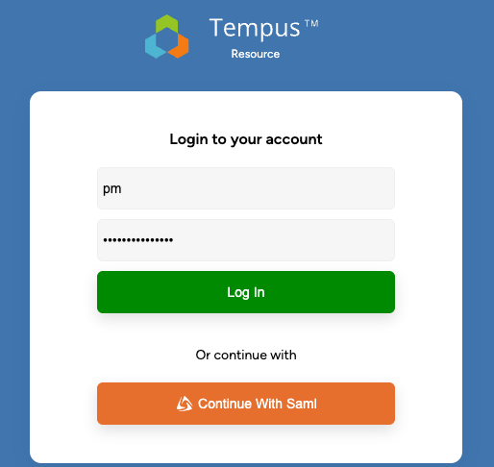
• Sign in using your standard or test credentials.
• For testing purposes you can find the credentials here: Testing Excel

Homescreen for PM/SM
PM/SM sees a focused set of tiles: Project Management and Report Management. The "+" badge on Project Management opens the Create Project dialog directly.
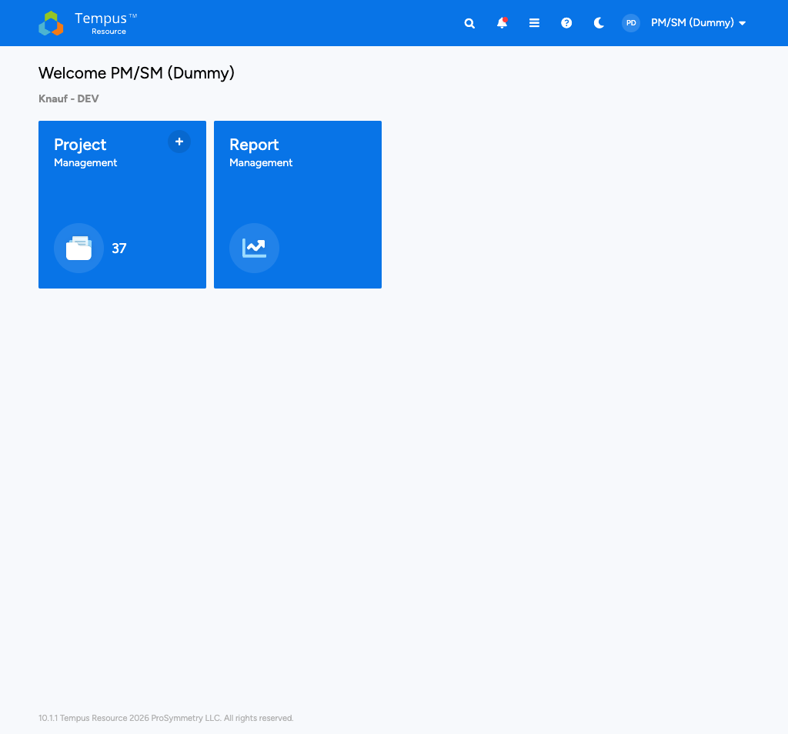
PM/SM (Dummy) homescreen

Homescreen for RM
RM typically sees more cross-project tiles, for example Resource Management, Bulk Project Allocation Flatgrid, All Resource Requests / Resource Requests, and Bulk Resource Capacities. The exact set depends on Knauf's RM global role.
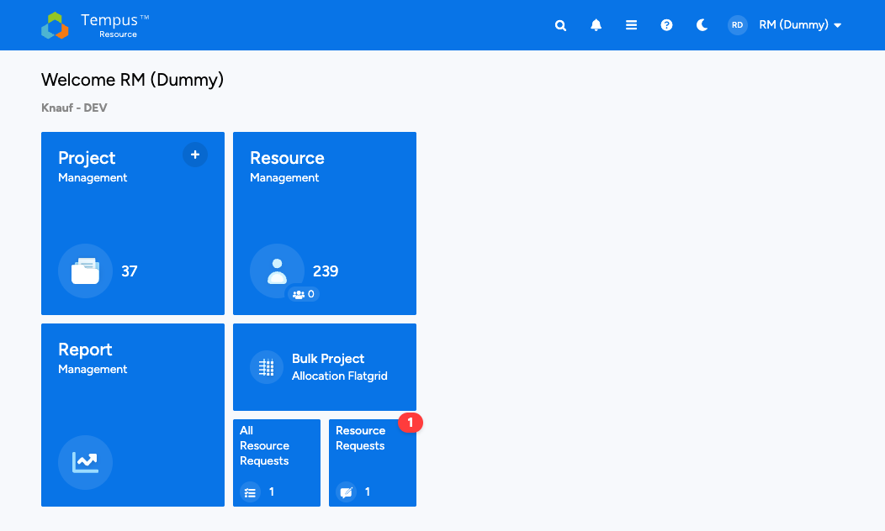
Note: If a screen mentioned in this guide is missing from your homescreen, you are most likely not granted that area. Ask the Knauf Tempus Admin if access is intended.

Top Bar Reference
The blue top bar is identical on every screen. Each icon is a single click.
Icon | Name | What it does
 | Home | Back to the homescreen.
 | Search | Global search across projects, resources, reports.
 | Notifications | In-app notifications. A red dot means unread items.
 | Menu | Full navigation drawer with every module you have access to.
 | Help | Opens the ProSymmetry Help Center in a new tab.
 | Theme | Toggle dark mode.
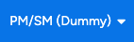 | Profile | Profile, Subscriptions, Logout.

Notification Subscriptions
How to
1. Click your avatar > Subscriptions.
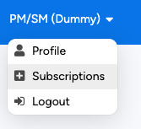
2. On the Project tab, add the projects you want to follow.
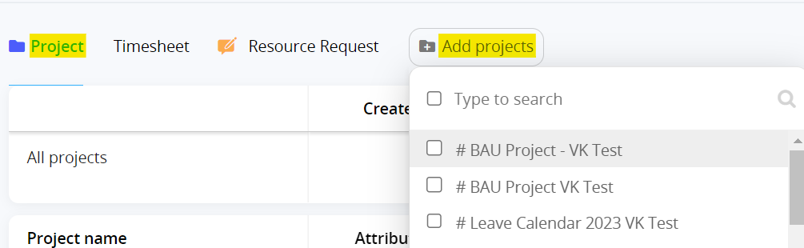
3. For each project, enable Attributes, Allocations, and Deleted notifications.
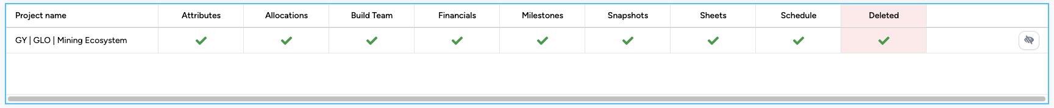
4. On the Resource Request tab, enable the outcomes you care about for requests you submit.
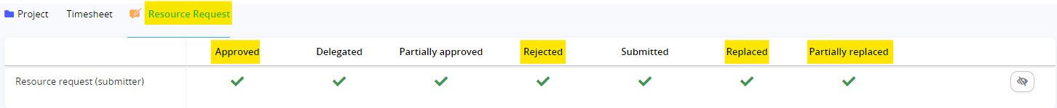
5. To unsubscribe from a project, click 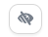 at the very right.

Find and Open a Project
Both

At a glance
• The Project Management tile lists every project you can see.
• Use Search (contains-match) to find a project by any name fragment.
• The blue P badge next to a project marks a Proposal (not yet approved).

Open Project Management
Click the Project Management tile to open the Project List, where you have access to the entire project repository.
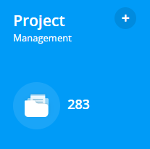

View Management
- There are various options to customise the Project management grid.
  - Search for a project or projects by name via the search field, which uses “contains” logic.
  - Filter projects by applying as many filters as needed.
  - Add or remove Columns.
  - Group projects based on any attribute(s). Each grouping level will display the group by attribute, attribute value, and the count of projects contained in the grouping.
  - Use Quick filters to navigate to relevant projects e.g., “my projects” will show projects where the logged in user is assigned as the Project Owner
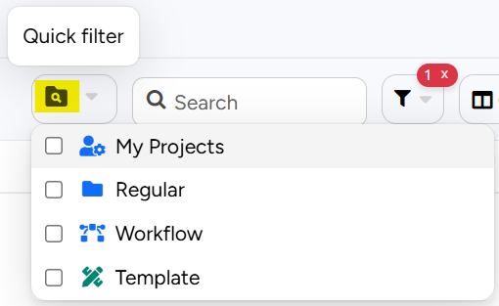
- Open the View Management dialog by clicking on the view name to the right of the Group By option.
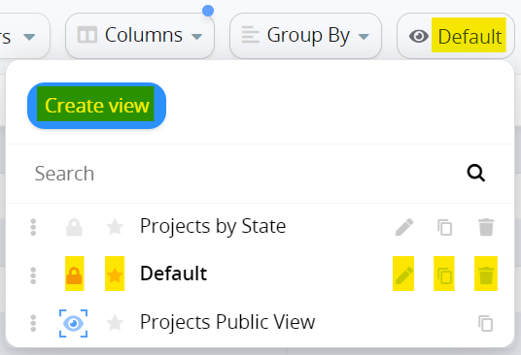

- Create a new view by clicking Create view
- Lock a view in its current state by clicking
- Select a Default view by clicking
- Edit a view by clicking
- Clone a view by clicking
- Delete a view altogether by clicking
- Public views are denoted by the blue eye shaped icon 

These views cannot be edited in any way as they are administratively defined.
Always clone a public view using the copy icon
into it.
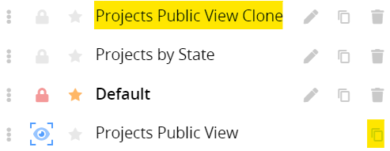
- Project navigation using Advanced Tooltips
Hovering over any project name in the Project Management grid will reveal all areas of the project that the user has access to. Clicking on any area will navigate directly to the selected area of the project.

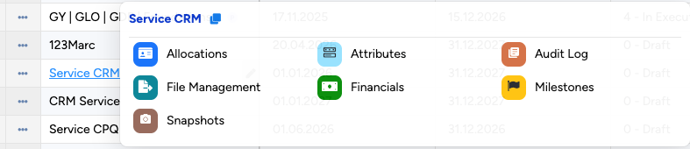

Tip: Public views (with the  eye) are managed centrally by Knauf's Tempus admins. Always clone them before changing anything - your edits stay in the cloned copy.

PROJECT ATTRIBUTES (master data)
- Clicking on any project name in the grid will navigate to the individual project attributes screen.

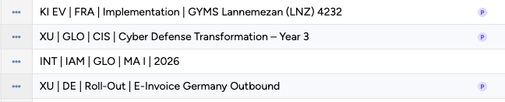
- At here you find relevant Attributes for the projects.
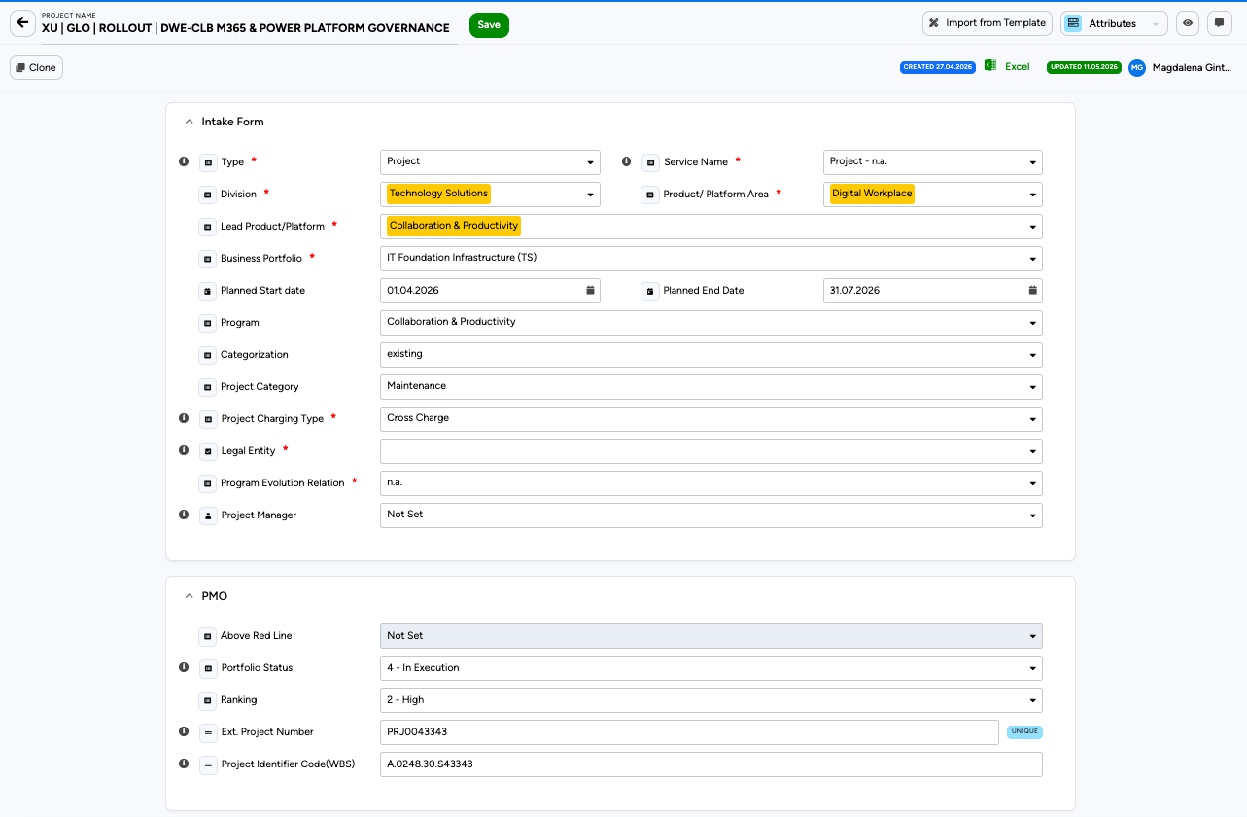

A practical edit loop
The typical edit loop on this page is short:
- Open the project from the Project Management Grid.
- Make changes to the fields you need to update.
- Click Save 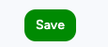.
- Wait for the green confirmation toast in the lower-right corner.
- Switch to the next view if needed via the view selector in box.

SINGLE PROJECT ALLOCATION GRID

- Clicking at the dropdown in the very right top corner will navigate you to the Project Allocation grid.


- Once a project has been created, and a valid date range has been entered, the Single Project Allocation grid will become available.
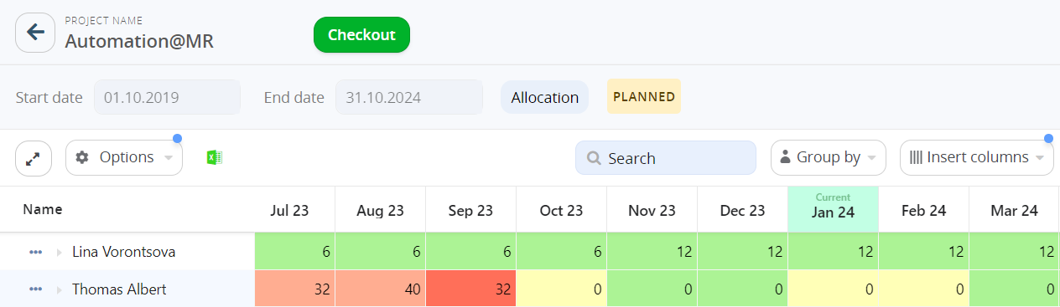
GRID OVERVIEW
- The Project Name and Checkout button is located at the top of the grid.
To make any changes to a project, it must first be checked out.
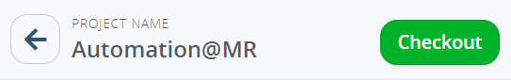
- Basic options to update the grid are in the ribbon below the project start and end date.
- Expand the grid with one-click by clicking on 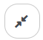
- Search for an assigned resource when the grid is grouped by Resource and for a task name when the grid is grouped by Task.
- Group by either Resource or Task.
- Insert Columns to view project, resource, or assignment attributes.
- Update Time Granularity by which allocations are displayed. Month is the recommended granularity for Knauf.
- Choose the Capacity unit in which allocations are entered/displayed.

- Advanced grid options can be found in the Options menu in the ribbon below the project timeframe.
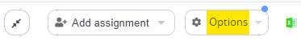
- Enabling the Total Column will display a column with total Hours or Mandays.
When viewing the grid in FTE or FTE%, it will display the average.
- A Resource Heatmap will display colours based on overall allocation% of a resource.
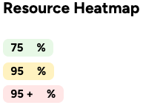

- A Resource Request Heatmap will display colours based on the resource request status.
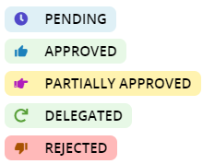

- Enabling Overlay Heatmap for Rows will apply the selected heatmap on individual grid rows.
- Enabling Overlay Heatmap for Groups will apply the selected heatmap on groupings.
- Tasks to Show will filter tasks and hide the task type that is not selected – _generic or non-generic.
- The Date Range Filter will filter the grid for a specific timeframe without amending project timeframe.
Note: If you cannot find a project that should be there, the most likely reason is project-level security. PM/SM only sees projects where the security group grants access. Ask the project owner or the Tempus admin to add you.

Attributes | Master data (intake form, PMO).
Allocations | Resource and labor cost planning.
Financials | Non-labor cost lines, planned vs. actual.
Files | Attachments.

Create a Project
PM/SM

• PM/SM creates Regular Projects only. There are two ways to start creating a regular project in Tempus.
- Either click on the plus icon on the Work Management tile on the homepage.
- Or click on Create Work towards the top-left of the Work Management Grid and select Regular Work.
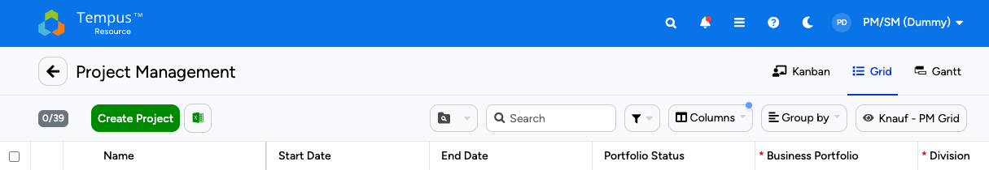
• A new project opens directly in the Attributes view with an intake form to fill in. Mandatory fields are marked with a red asterisk; you cannot save until they are set.

• To help you with selections color coding is in place, and you can use the text search too.
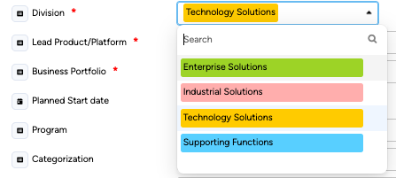 | 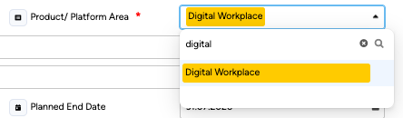 | 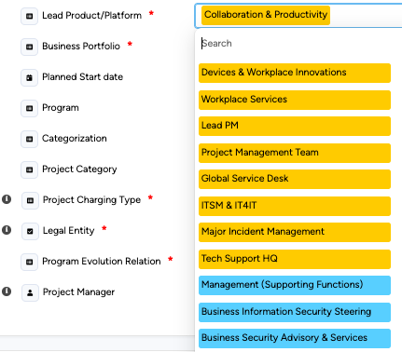

Project Master Data (Attributes)
PM/SM

• The Attributes view holds all master data and is the first place to clean up after creating a project.
• The form is split into Intake Form and PMO sections.
• Edit directly in the view, click Save in the top-left. No separate checkout step for attributes.
• The colour-coded drop-down menu displays valid combinations of Knauf attributes.

Editing Rules
Rule | Effect
Lock conflict | If another user has the project locked, your save is rejected. Wait for the lock to clear.
Audit trail | Every change writes to the Audit Log; the CREATED / UPDATED badges show who and when.
Cascade | Some attributes (Division, Business Portfolio) drive cost roll-ups; changes ripple into portfolio reports.
Green badge | Cosmetic Knauf hint that the value is a recommended pick for the current Division / Area combination.

What to Maintain
When you... | Update this
Get a new project name from the business | Project name, Ext. Project Number, Project Identifier Code (WBS).
Get scope clarity | Categorization (new / existing / extension), Project Category.
Get scheduling | Planned Start / End Date.
Get the responsible PM | Project Manager.
Reach a portfolio milestone | Portfolio Status (e.g. 0 - Draft -> 1 - Approved).

What PM/SM Cannot See / Edit
Block | Who maintains it
System Fields (ID, Security Group, Assignment Workflow) | Admin Light / IT Controlling.
Dependency Section (predecessor / successor) | Admin Light / PPM.
Financial Categories master data | IT Controlling.
Resource Hierarchy | RM / Admin.

Warning: If a mandatory field is missing or a duplicate Ext. Project Number is detected, the Create click fails silently. Scroll through the intake form and look for red borders or the duplicate tooltip on the Ext. Project Number field.

Tip: Use the Search in the Project Management grid to find your project again, even after you renamed it - search is contains-based. Clone the public and add your own data to the view for the best user experience.

Plan Resources (Allocations)
PM/SM | RM
• The Allocations view of a project is the home for resource planning. PM/SM works here for their own projects; RM uses it when supporting a specific project.
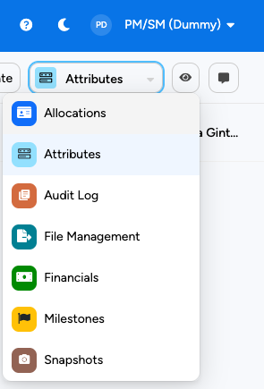
• Standard unit at Knauf is Manday; switch to € Cost for a live euro view.
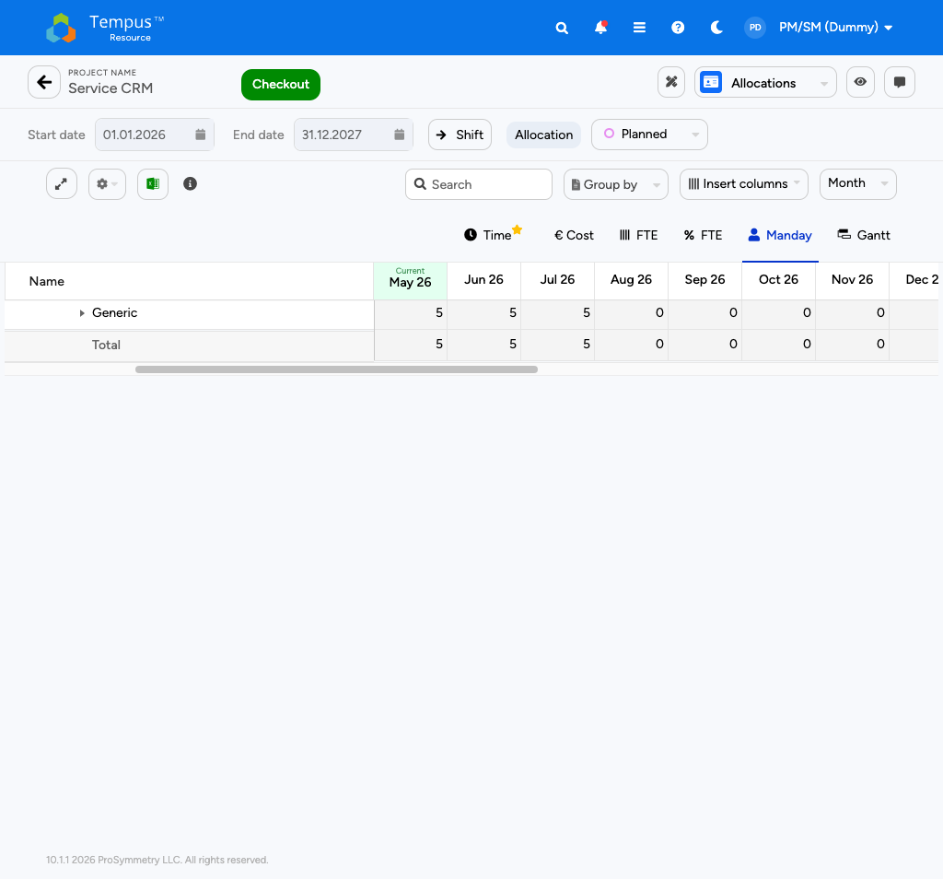
• Default grain is Month. You can change to Day, Week, Quarter, or Year.
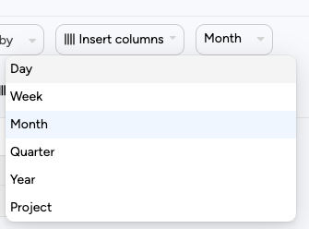
• Editing requires clicking on 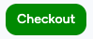 first. Save with Check In; release without saving with 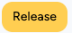.
¨¨¨

Toolbar Reference
Control | Purpose
Checkout (green) | Acquire the edit lock.
Start / End date | Restrict the visible window.
Shift | Bulk-shift assignments by N months.
Allocation / Assignment toggle | Switch between project-level and assignment-level edits.
Planned / Actual | Switch the editable series.
Expand all | Open all groups.
Options (gear) | Heatmaps, totals, filters.
Excel export | Export the current grid.
Group by | Group rows by attribute.
Insert columns | Add resource / project / assignment attributes as columns.
Grain selector | Day / Week / Month (default) / Quarter / Year.
Unit tabs | Time, € Cost, FTE, FTE %, Manday (default), Gantt.

Add a Resource
- Click Checkout to acquire the lock.


- Expand the grid by clicking on 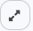 above the Name column in the grid.

- In the empty row at the bottom of the grid, start typing the resource or resource role (for example *Business Analyst).
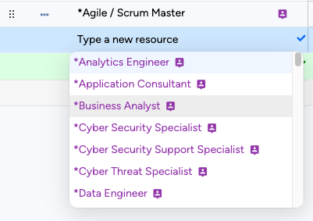

- To add a single resource, click on a blue cell reading Type a new resource to start typing the name of the resource or select a resource from the dropdown. Type-ahead functionality narrows down the available resources to simplify resource loading.
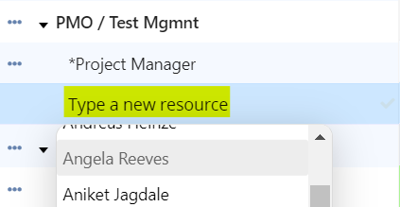

- To add multiple resources to one or multiple tasks, click on Add assignment to reveal the New Assignment dialog. Choose resources to the left and tasks to the right and click Add.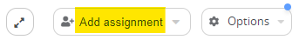
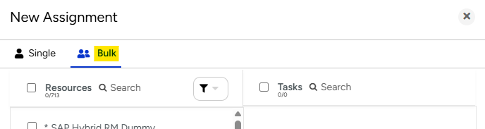

- Enter any relevant assignment attributes like Module, Role, Skills, Additional comments.
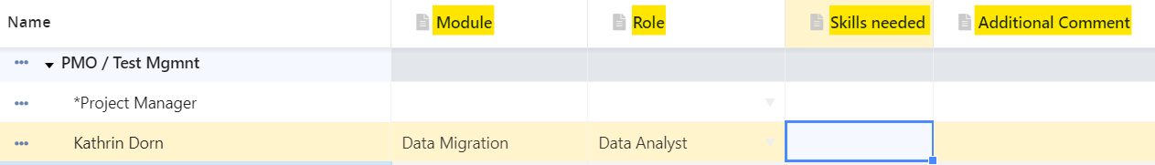

- Enter planned Mandays per month in each cell. Drag, copy-paste (Ctrl+c or v), or use the keyboard to fill ranges.
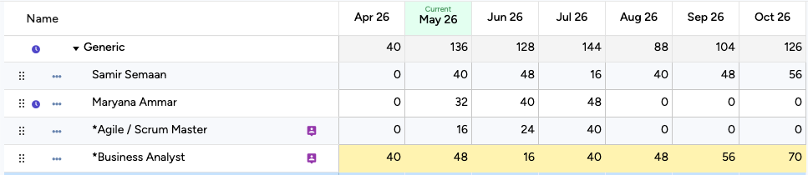

- To request additional capacity from a named resource that has already been allocated to a project, enter the new total requested allocation directly in the grid.

- Click 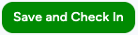at the top to persist; this also creates the resource request for RM approval.

Tip: The * prefix marks demand-planning (generic) roles. Use them in early planning; let RM replace them with named resources.

